



Excel and Copilot for Data Productivity
LAB MANUAL

Disclaimer: The content is curated from online/offline resources and used for educational purpose only
Lab 1.3 – AI Automation in Excel
Task
You will use a provided Weekly Attendance and Skill Score dataset in Excel and work with Microsoft Copilot as your AI assistant to generate formulas, analyse student performance, and create an automated weekly report. You will practise using AI to build formulas, flag at-risk students, and turn raw data into a professional summary.
Learners will learn to:
- Enter and review structured data in Excel
- Use AI to generate formulas
- Analyse performance automatically
- Create AI-generated reports
- Understand a simple workflow automation pattern
Equipment Required
- Computer with internet connection and web browser
- Access to Microsoft Excel (Online or Desktop)
- Access to Microsoft Copilot (in browser or integrated with Excel)
- Provided file: Weekly_Progress.xlsx (contains the attendance and skill score dataset)
Prerequisites
- Ability to open a workbook and navigate sheets in Excel
- Ability to identify and select cells, rows, columns, and tables
- Basic understanding of percentage, cut-off, and “at-risk” concepts in education
Problem Statement
You are a teacher tracking weekly class attendance and skill development for your students. The training coordinator wants a quick weekly summary that highlights:
- Students with attendance below 75%
- Students who need skill improvement
- Students who are “high risk” (both low attendance and low skill)
- An overall view of class performance
Manually writing and maintaining all formulas and reports can be time-consuming. Your challenge is to use Microsoft Copilot with Excel to generate formulas, flag students automatically, and create a weekly progress report within 20 minutes.

Dataset Description
The provided Excel workbook contains a sheet named Weekly_Progress with the following columns:
- Student Name – Name of the student
- Total Classes – Total number of classes held in the week
- Classes Attended – Number of classes attended by the student
- Skill Score (10) – Skill score out of 10
The sheet also contains data for multiple students (for example: Aman, Riya, Karan, Meena, etc.).
Procedure
You may use either:
- Excel Online in one browser tab and Copilot in another browser tab, OR
- Excel Desktop with Copilot integrated in the Excel interface
Follow the steps in order.
Part 1: Open the Dataset in Excel
- Open Excel (Online or Desktop).
- Open the file Weekly_Progress.xlsx.
- Go to the Weekly_Progress sheet and confirm that you can see the columns: Student Name, Total Classes, Classes Attended, and Skill Score (10).
- Select any cell inside the data range.
- Convert the range to a table:
  - In Excel Online: Go to the Insert tab and click Table.
  - In Excel Desktop: Go to Insert and select Table.
- Ensure that My table has headers is checked, then click OK.
Part 2: Connect to Copilot and Describe Your Data
You can access Copilot in one of two ways:
- Option A: Open Copilot in a separate browser tab.
- Option B: Use Copilot directly inside Excel if it is available in your version.
In Copilot, briefly describe your dataset. You can use this prompt and adapt it: I am working with an Excel table named students. The columns are Student Name, Total Classes, Classes Attended, and Skill Score (10). I want help creating formulas to calculate attendance percentage and to flag students based on attendance and skill.
- Read Copilot’s response. Note how it restates or understands your data.
Part 3: AI Formula – Attendance Percentage
Step 1 – Ask Copilot for the formula
- In Copilot, type: Generate an Excel formula to calculate attendance percentage using Total Classes and Classes Attended in the table named students, using column names.
- Note the formula Copilot suggests. It will be similar to:
=[@[Classes Attended]]/[@[Total Classes]]
Step 2 – Create the Attendance % column
- In Excel, add a new column to the table with the header Attendance (%).
- Click the first data cell under Attendance (%).
- Enter or paste the formula provided by Copilot.
- Press Enter. Excel will automatically fill the formula for all rows in the table.
- Format the Attendance (%) column as a percentage from the Home tab.
Expected Output
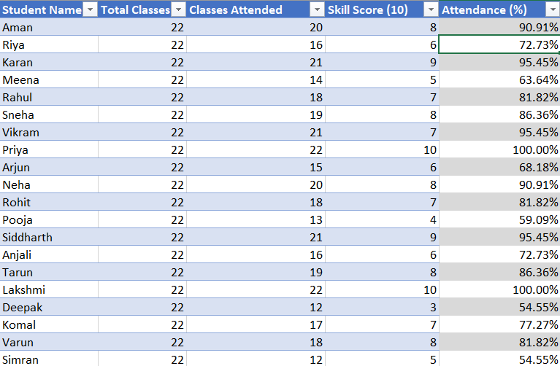

Part 4: AI Formula – Attendance Status (Below 75%)
Step 1 – Ask Copilot for the formula
- In Copilot, type: Generate an Excel formula to flag students below 75% attendance, using the Attendance % in the students table.
- Copilot may suggest a formula similar to:
=IF([@[Attendance (%)]]<75%,"Below 75%","OK")
Step 2 – Apply the Attendance Status formula
- In Excel, add a new column with the header Attendance Status.
- In the first data cell under Attendance Status, enter or paste the formula suggested by Copilot.
- Press Enter and ensure the formula fills down for all students.
Expected Output
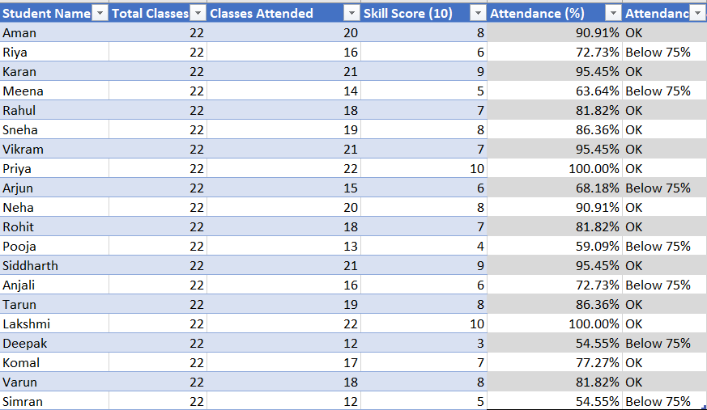

Part 5: AI Formula – Skill Improvement Flag
Step 1 – Ask Copilot for the formula
- In Copilot, type: Generate an Excel formula to flag students who need skill improvement based on Skill Score (10). The cut-off is 7.
- Copilot may suggest a formula such as:
=IF([@[Skill Score (10)]]<7,"Needs Improvement","Satisfactory")
Step 2 – Apply the Skill Improvement formula
- In Excel, add a new column with the header Skill Improvement.
- Enter or paste the formula in the first data cell under Skill Improvement.
- Press Enter and check that the formula fills down for all rows.
Expected Output
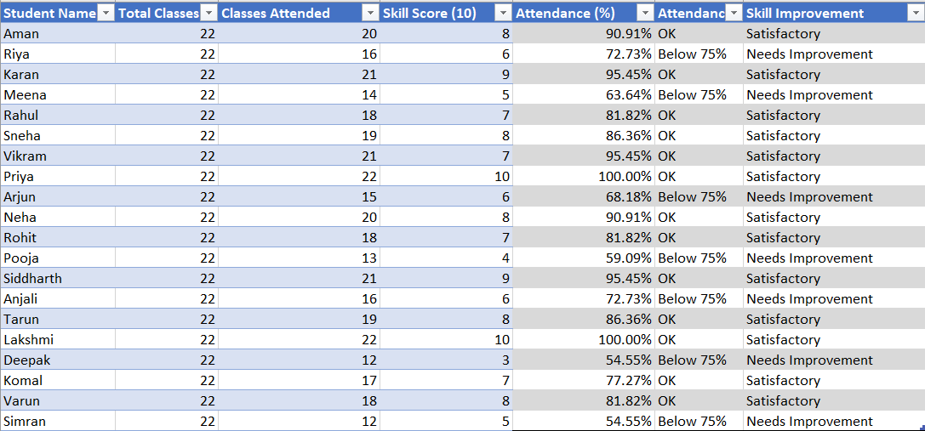
Part 6: AI Formula – High Risk Students (Attendance + Skill)
Step 1 – Ask Copilot for the formula
- In Copilot, type: Generate an Excel formula for students who are high risk: attendance below 75% and skill score below 7. Flag them as "High Risk" and leave the cell blank otherwise.
- Copilot may suggest a formula like:
=IF(AND([@[Attendance (%)]]<75%,[@[Skill Score (10)]]<7),"High Risk","")
Step 2 – Apply the High Risk formula
- In Excel, add a new column with the header Performance Status.
- Enter or paste the formula in the first data cell under Performance Status.
- Press Enter so the formula fills down for all students.
Expected Output
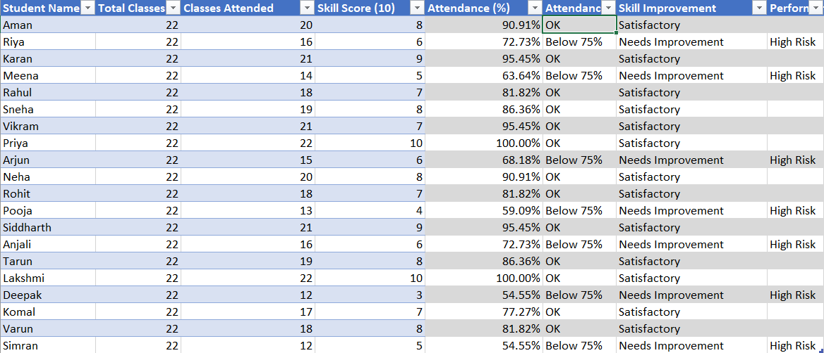
Part 7: Conditional Formatting for High Risk Students
You can apply conditional formatting in different ways.
Option A – Highlight High Risk rows
- Select the Performance Status column or the entire table.
- Go to the Home tab and click Conditional Formatting.
- Choose Highlight Cells Rules and select Text that Contains
- Enter High Risk and choose a fill color (for example, light red).
- Click OK and check that all “High Risk” students are highlighted.
Option B – Ask Copilot for conditional formatting steps
- In Copilot, type: Tell me how to apply conditional formatting in Excel to highlight the rows where Performance Status is "High Risk".
- Follow the steps suggested and apply them to your students table.
Expected Output
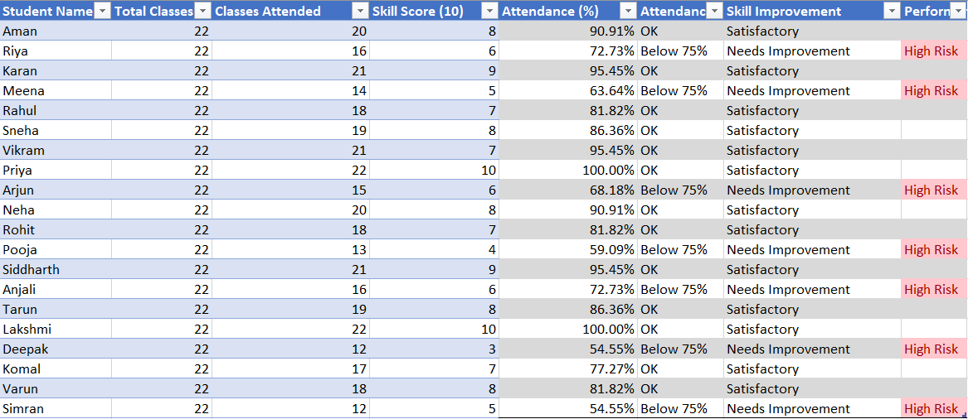

Part 8: AI Data Analysis – Class Performance
Step 1 – Ask Copilot for analysis
- Copy the table (including the new calculated columns) or describe it.
- In Copilot, type a prompt similar to: Provide an analysis of overall class performance based on this table. Identify low attendance students, high risk students, and skill improvement suggestions. Also give a brief class overview.
- Review the analysis generated by Copilot.
- Note the key points about:
  - Low attendance students
  - High risk students
  - Skill improvement suggestions
  - Overall class strengths and gaps
Part 9: AI Report Generation – Weekly Training Progress
Step 1 – Ask Copilot to draft a report
- In Copilot, type a prompt such as: Create a professional weekly training progress report based on this data for submission to the training coordinator. Include a summary, key statistics, high risk students, and recommendations.
- Read the report generated by Copilot.
Step 2 – Save or copy the report
- Copy the report text into a Word document or a new sheet in Excel, as instructed by your trainer.
- Add a title such as Weekly Training Progress Report and your name.
Part 10: Self-Paced Extension Task
- Ask Copilot to adapt the report for a different audience. For example:
Rewrite this weekly training progress report for parents instead of the training coordinator. Use simple language and a supportive tone.
- Compare the two versions (coordinator vs parents) and note how language and focus change.
Workflow Automation Concept
This lab demonstrates a simple automation pattern:
- Enter or update data each week in Excel
- Use formulas (assisted by AI) to calculate attendance and flags
- Use Copilot to analyse and generate a weekly report
- Repeat the same process each week with minimal changes
Conclusion / Expected Output
By the end of this lab, each learner should have:
- An Excel sheet (Weekly_Progress.xlsx) with the data formatted as a table
- Calculated Attendance %, Attendance Status, Skill Improvement, and Performance Status columns
- Conditional formatting applied to highlight “High Risk” students
- An AI-generated analysis of class performance
- A weekly performance report for the training coordinator and a modified version for parents (self-paced extension)
Discussion Questions:
- How did using Copilot change the way you think about creating formulas in Excel?
- Which parts of this task would you still want your students to do manually, and why?
- How could you use this kind of AI-assisted attendance and performance sheet in your own classroom or training context?
- What checks would you put in place to verify that Copilot’s formulas and analysis are correct before acting on them?
- How might you differentiate the AI-generated reports for different stakeholders (students, parents, school leaders)?
- If your students had access to Copilot, how would you design assignments so that AI is used as a learning support rather than a shortcut?

Disclaimer:
The results you have generated are using Artificial Intelligence (AI) and are intended for informational and preliminary analysis purposes only. While efforts are made to ensure accuracy, users are strongly advised to independently review, validate, and verify all calculations, observations, and results before relying on them for interpretation, reporting, or decision-making.

